Microsoft logo

Robotic Process Automation in a Day

Lab 3 – Use Input and Output Parameters

30 mins

April 2023

Applies to Power Automate Desktop v. 2.31.105.23101 ([more](https://learn.microsoft.com/en-us/power-platform/released-versions/power-automate-desktop))



This document is provided “as-is.” Information and views expressed in this document, including URL and other Internet Web site references, may change without notice. You bear the risk of  
using it. Some examples are fictitious and are for illustration only. No real association is intended  
or inferred. This document does not provide you with any legal rights to any intellectual property in any Microsoft product. You may copy and use this document for your internal reference purposes.

© 2021 Microsoft Corporation. All rights reserved

## Lab Overview

You will complete the following tasks in this lab:

* Create a new Power Automate Desktop flow with predefined inputs
* Record actions performed in the desktop-based Contoso Invoicing application using these inputs, and capturing application data for output
* Perform a test run of the new desktop flow with a new set of inputs

## Prerequisites

This lab builds on the initial setup lab (Lab 1) – ensure all tasks are complete.

**Important Additional Prerequisite:** As you will be recording actions performed in your UI in this lab, **you will have the best experience if you view the lab instructions on a separate device or in a printout**. You can still complete the lab while pursuing the instructions during UI action recording, but you will have to perform extra work to cut the recorded actions of viewing the instructions from the UI flow.

# Use input and output parameters

1. Open the test profile in a browser and navigate to <https://powerautomate.microsoft.com>
2. Open Contoso Invoicing app.
3. Select My flows > Desktop flows.

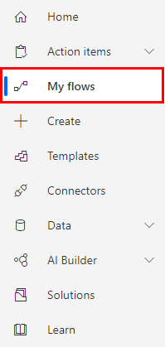

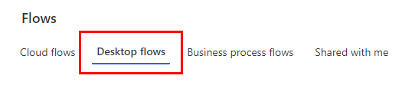

1. Edit Enter an invoice flow by clicking pencil icon

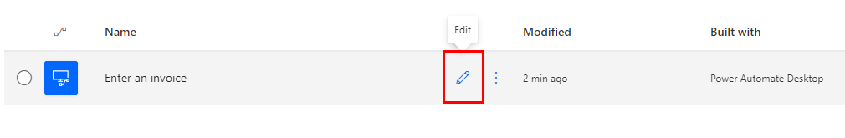

1. Click Launch app.

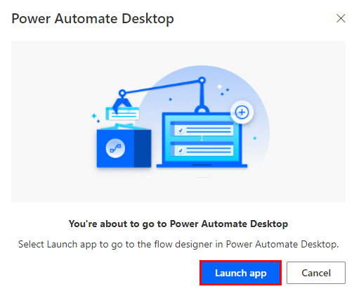

1. Power Automate Desktop provides the ability to receive input values from Cloud flows and return values using output values. We will now create a series of input values by clicking Input/output variables, then click plus icon - Input to add your first input.

1. Use these values to setup the first input:

* Variable Type: Input
* Variable Name: Amount
* Data type: Number
* Default value: 500
* External Name: Amount
* Description: Amount

1. Click Save.

1. Click plus icon > Input to add 2 more inputs.

1. Use these values to setup two new added inputs.

* Variable Type: Input
* Variable Name: Contact
* Data type: Text
* Default value: b.friday@wingtiptoys.com
* External Name: Contact
* Description: Contact email

* Variable Type: Input
* Variable Name: Account
* Data type: Text
* Default value: WingTip Toys
* External Name: Accountname
* Description: Account name

1. Click Save.

1. On the right-side Input/output variables, click plus icon > Output to add your first output.

1. Use these values to setup the first output:

* Variable Name: InvoiceID
* Data type: Number
* External Name: InvoiceID
* Description: InvoiceID

1. After providing the required values in each field, click Save to proceed.

1. Within our process, we now need to add an action to set this output. Please ensure the Contoso application is still running. Drag the Get details of a UI element’s attribute in a window from UI automation > Data extraction folder under Step 8 in your actions.

1. Click on the UI element dropdown and then click Add UI element.

Note: A red rectangle appears on the desktop while hovering the mouse over the elements.

1. Go to **Contoso Invoicing app**, move the mouse over the value that belongs to ID number. Hold the CTRL key on your keyboard and then Left-Click to select the element (You may have a different ID than the number displayed here).

1. Once you selected the element, you will see the value is being recorded and the UI element picker disappears.

1. Click Save.

**Note:** This action will automatically create a variable called AttributeValue as an output that we can refer to in subsequent actions within Power Automate Desktop.

1. Add Convert text to number action from Text folder.

1. We will now set an **InvoiceID** variable that will be used to capture the Invoice ID that we previously captured in step 21. This allows us to use the Invoice ID in downstream processes or from our API flow that will be created in a future lab. Use below information to fill out Set variable:

* Text to convert: %AttributeValue%
* Variables produced: %InvoiceID%

**Note:** You can also use the {x} button to assign our **AttributeValue** from a dropdown list.

1. Click **Save**.
2. Go back to Step 5 (Edit ‘TextBox’ with ‘WingTip Toys) of your UI flow, click … icon. Select Edit.

1. Delete the value in Text to fill-in. Double click Account (One of the inputs we created earlier) by clicking Select Account > Account.

1. Click Save.

1. Follow the same steps above to change the value in Text to fill-in in Step 6 and Step 7.

* Use Input Contact for Step 6
* Use Input Amount for Step 7

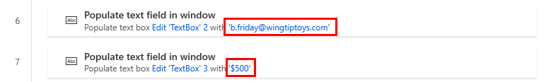

1. Once you’re done, your actions should look like the screenshot below.

1. Click Save.

1. Now you can test your flow by clicking Run.

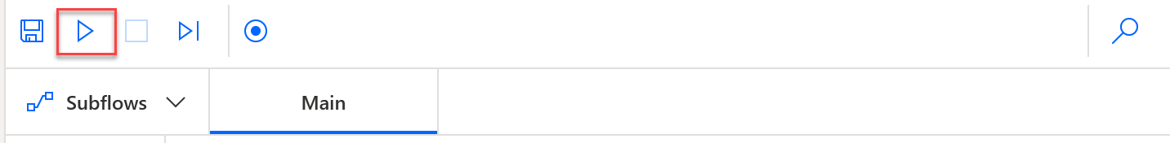

Check your knowledge

Lab 3

10 mins

1. If you need to pass parameters from a Cloud flow into a Desktop flow, where do you define these values _______?
2. Run
3. Run next action
4. Input/output variables
5. None of the above

Answer: C. Input/output variables allow the maker to establish parameters that can be sent from a Cloud flow. In addition, output variables can be used to send data back to Cloud flows.

1. We need to hold the _______ key on keyboard and then _______ to select the element.
2. Shift + Right-Click
3. Shift + Left-Click
4. CTRL + Left-Click
5. CTRL + Right-Click

Answer: C. CTRL + Left-Click

1. Which of the following action allows us to use Invoice ID in downstream desktop flow actions or is required to return the value to ca cloud flow?
2. Create new list
3. Convert text to number
4. Add item to list
5. Increase variable

Answer: B. Set Convert text to number - This will capture the Invoice ID and convert it to number, as that data type is expected by the output variable. It will allow us to use the Invoice ID in downstream processes or send back to our cloud flow that will be created in a future labs.

Information in this document, including URL and other Internet Web site references,  
is subject to change without notice. Unless otherwise noted, the example companies, organizations, products, domain names, e-mail addresses, logos, people, places, and events depicted herein are fictitious, and no association with any real company, organization, product, domain name, e-mail address, logo, person, place or event is intended or should be inferred. Complying with all applicable copyright laws is the responsibility of the user. Without limiting the rights under copyright, no part of this document may be reproduced, stored in or introduced into a retrieval system, or transmitted in any form or by any means (electronic, mechanical, photocopying, recording, or otherwise), or for any purpose, without the express written permission of Microsoft Corporation.

Microsoft may have patents, patent applications, trademarks, copyrights, or other intellectual property rights covering subject matter in this document. Except as expressly provided in any written license agreement from Microsoft, the furnishing of this document does not give you any license to these patents, trademarks, copyrights, or other intellectual property.

The names of manufacturers, products, or URLs are provided for informational purposes only and Microsoft makes no representations or warranties, either expressed, implied, or statutory, regarding these manufacturers or the use of the products with any Microsoft technologies.  
The inclusion of a manufacturer or product does not imply endorsement of Microsoft of the manufacturer or product. Links may be provided to third party sites. Such sites are not under the control of Microsoft and Microsoft is not responsible for the contents of any linked site or any link contained in a linked site, or any changes or updates to such sites. Microsoft is not responsible for webcasting or any other form of transmission received from any linked site. Microsoft is providing these links to you only as a convenience, and the inclusion of any link does not imply endorsement of Microsoft of the site or the products contained therein.

© 2021 Microsoft Corporation. All rights reserved.

Microsoft and the trademarks listed at https://www.microsoft.com/enus/legal/intellectualproperty/Trademarks/Usage/General.aspx  
are trademarks of the Microsoft group of companies. All other trademarks are property of their respective owners.